Money Lab - Week 4
Name: Nimesh Chandupa Peiris 152212239 SYD 366 NCC

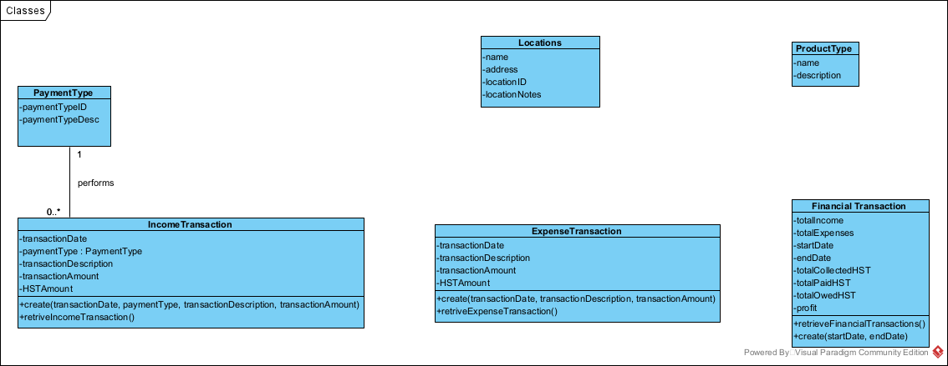

Class public PaymentType{
Int paymentTypeID;
String paymentTypeDesc;
}

Class public IncomeTransaction {
Int transactiondate;
PaymentType paymentType;
String transactionDescription;
Double transactionAmount;
Double HSTAmount;

create(transactionDate, paymentType, transactionDescription, transactionAmount)
retriveIncomeTransaction()
}

Class public ExpenseTransaction {

Int transactionDate;
String transactionDescription;
Double transactionAmount;
Double HSTAmount;

create(transactionDate, transactionDescription, transactionAmount)
retriveExpenseTransaction()
}

Class public FinancialTransaction{
Double totalIncome;
Double totalExpenses;
Int startDate;
Int endDate;
Double totalCollectedHST;
Double totalPaidHST;
Double totalOwedHST;
Double profit;

create(startDate, endDate);
retrieveFinancialTransactions;
}

